**Rtl_Dual Beacon Data Collector Help File**

**Section1: How to set up and use rtl_sdr to receive the KiwiSAT Dual Band Beacons.**

**Introduction:** rtl_sdr is a CLI (Command Line Interface) program for use with RTL-SDR dongles. It comes as part of the GNU Radio suite of programs that are included with some Linux distributions or as a pre-built binary for Windows. The **Rtl Dual Beacon Data Collector** uses two instances of this program to create 8 bit I/Q files that can be used by the KiwiSAT_TEC program to calculate the Phase Difference (Dif Phase) between the 437.425 MHz and 145.865 MHz beacon signals and hence calculate the Total Electron Content (TEC) of the ionospheric path between the observer and the satellite.

**Theory:**   In the rtl dongle documentation, it mentions that the RTL chip produces 8 bit data   
for the I and Q files.  
Looking at a sample I/Q file of a test signal with a hex editor, you can see a string of 2 digit hex numbers. Like this:

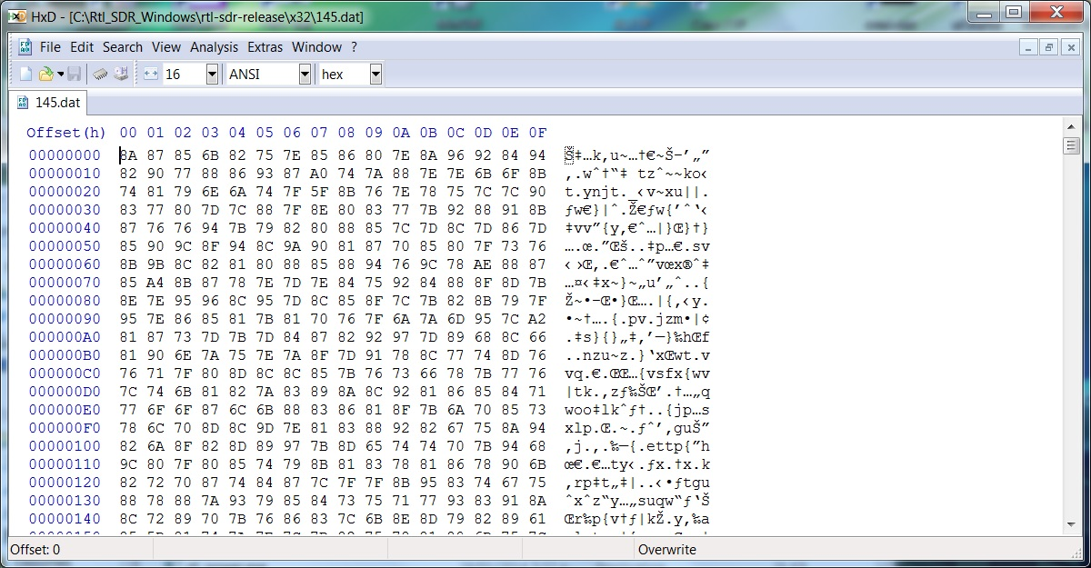

2 digit hex is equivalent to an 8 bit binary number.  
So looking at the test file, the first sample **I** has a value of 8A and the **Q** has a value of 87.  
The range of hex values must be from 00 to FF, or decimal 0 to 255.  
 If we assume 00 is the minimum then we can make that the maximum negative value of I or Q.  
Looking at our first sample:  
 8A = 138 (decimal) and 87 = 135 (decimal)  
      Subtract 128 from each reading 138 -128 = 10 (to account for the negative values)   
      for I and  135 - 128 = 7 for Q.  
      The phase of our sample is arctan of Q/I = arctan 0.700 = 34.992 degrees or 0.6107 radians.  
     The amplitude of our first sample is sqrt of I squared + Q squared = sqrt 149 = 12.2066.  
 If we now repeat this for a different test sample we will get a different phase angle.  
Now according to the TEC papers the 437 signals will have a more phase shift than the 145 signal.  
The differential phase is then the 437 phase - 145 phase.  
Going back to TEC paper Chapter05 equation 4 (reference 1) and putting in the numbers for KiwiSAT we get: Diff phase/6.614 = TEC.

**Rtl Dual Beacon Data Collector** is used to generate raw I/Q files and KiwiSAT_TEC program uses these formulae to calculate Diff Phase and TEC.

**To Start you need to install rtl_sdr:**

**Installation:** Download the zip file “RelWithDebInfo.zip” from : <https://www.dropbox.com/s/et95qzof3yfxs81/RelWithDebInfo.zip?dl=0>

Or from: <http://sdr.osmocom.org/trac/attachment/wiki/rtl-sdr/RelWithDebInfo.zip>

Unzip this file to a convenient location. This will give you a folder “rtl-sdr-release”.

Open “rtl-sdr-release” to show a list like this:

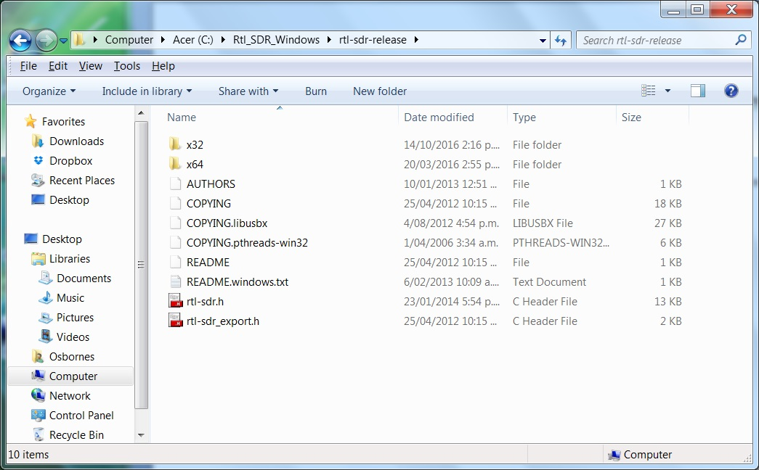

If you have a 32 bit machine, open the “x32” folder or the “x64” folder if you have a 64 bit machine. This should show a list like this:

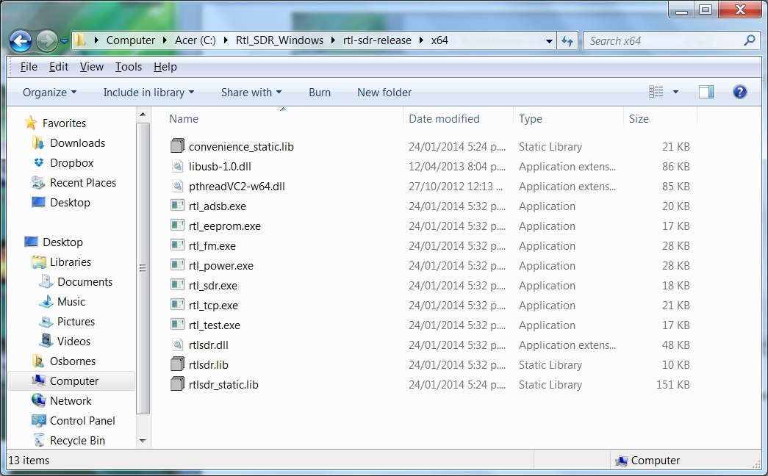

This gives you all the exe files and libraries required to run rtl_sdr.

Now copy the x32 or x64 files to a new folder C:\KiwiSAT\Rtl-SDR. This folder has been hard coded into the I/Q recording program **Rtl Dual Beacon Data Collector**.

You still need to load two drivers, one for each dongle.

**Dongle Modifications:** To obtain accurate results you need to simultaneously receive both beacon signals with a pair of RTL-SDR USB Dongles. These are available from various sources on the net. For example: <http://www.trademe.co.nz/electronics-photography/radio-equipment/amateur-radio/auction-1180987092.htm> . The dongles need to be modified to have a Master Clock on one Dongle and a Slave Clock on the second Dongle. The details on this modification are in Feature 3, here: <http://www.rtl-sdr.com/rtl-sdr-blog-v-3-dongles-user-guide/> Note: this modification applies only to RTL-SDR V3 Dongles.

**Installing the Drivers:** If you have not already done so, download the Zadig program from here: http://zadig.akeo.ie/ . Plug in both Dongles and run Zadig. From the “Options” Menu select “List All Devices”. Select the drop down list to display both dongles as Bulk-In, Interface (Interface 0) (2 entries) and Bulk-In, Interface (Interface 1) (2 entries).

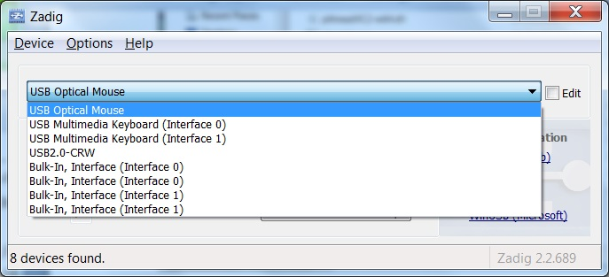

Select the first Bulk-Interface (Interface 0). Confirm that the WinUSB driver is selected and install if required. Repeat for all 4 Bulk-In Interface entries.

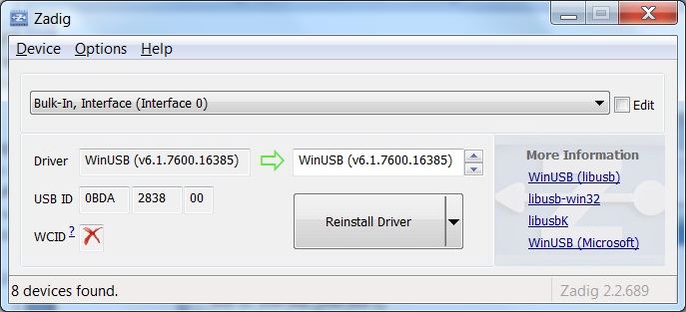

Both Dongles should now be operational. You could confirm this using SDR# or another SDR program.

**Confirm that rtl_sdr is running correctly:**

Since rtl_sdr is a CLI program, you will need to open a cmd (Command) window. To do this Open “Start”, “All Programs”, “Accessories”, “Run”. Type C:\Windows\System32\cmd.exe into the “Open” box. Alternatively, navigate to C:\Windows\System32\ and double click on “cmd.exe”.

Now “CD” (Change directory) to the folder that you put the rtl_sdr.exe in. See Installation section above. cd C:\KiwiSAT\Rtl-SDR.

Now type rtl_sdr to obtain a result as shown.

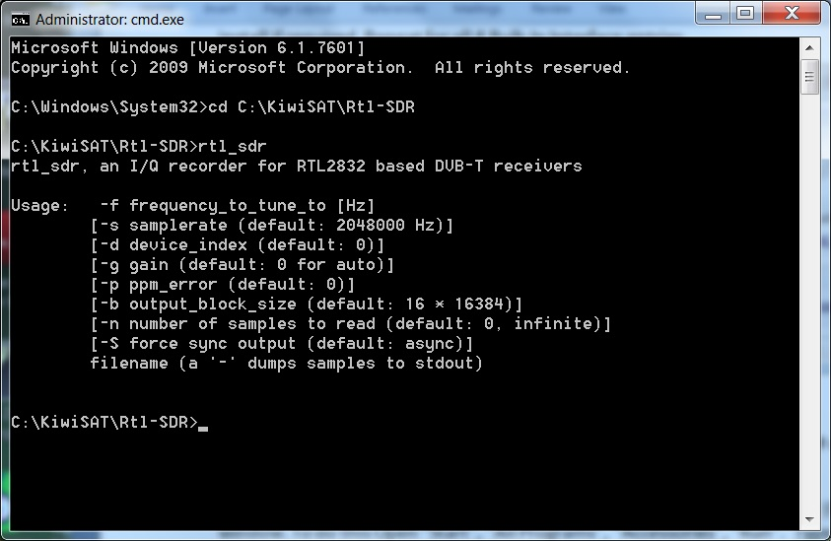

On the readout above you can see that rtl_sdr is an I/Q recorder for RTL2832 based DVB-T receivers.

To record an I/Q file from the 437.425 MHz beacon you will need to enter the following command line into the cmd window: rtl_sdr –f 437.425e6 –d 0 –s 0.25e6 –n 1e6 437.dat

This sets the frequency (-f) to 437.425 MHz, the device (-d) to 0 (Master oscillator Dongle?), the sample rate (-s) to 250,000 samples per second, the number of samples (-n) to 1,000,000 and the file to write the data to as 437.dat. This gives a data file of about 2 Mbytes.

Similarly To record an I/Q file from the 145.865 MHz beacon you will need to enter the following command line into the cmd window: rtl_sdr –f 145.865e6 –d 1 –s 0.25e6 –n 1e6 145.dat

This sets the frequency (-f) to 145.865 MHz, the device (-d) to 1 (Slave oscillator), the sample rate (-s) to 250,000 samples per second, the number of samples (-n) to 1,000,000 and the file to write the data to as 145.dat. This gives a second data file of about 2 Mbytes.

Using a hex editor, confirm that rtl_sdr has generated 437.dat and or 145.dat files similar to the first screen shot above.

**Section 2: Rtl Dual Beacon Data Collection Program**

**Introduction:** The KiwiSAT beacons run 9600 bps data in G3RUH FSK format. This format means that the transmit frequency is shifted at a rate of 4800 bps or 1 shift every 20.8333 milliseconds (usually). At the minimum sample rate of the rtl dongles of 250000 samples per second (or 250 samples per millisecond), 5208 samples would be required ensure the capture of at least 1 frequency transition.

The **Rtl Dual Beacon Data Collector** program has been written to automatically run two instances of rtl_sdr at the same time and take a 6000 samples of the I/Q data every 5 seconds over a 5 minute period. The 437_IQ.txt and 145_IQ.txt files generated by this program are used as the input for KiwiSAT_TEC.

**Data Collection:** Plug in the modified Dual Dongles (both). The program expects that the first dongle that is plugged in will receive 437 MHz and the second dongle to receive 145 MHz so connect the antennas accordingly.

To start data collection, click on the **“Run”** button. This should result in 2 instances of rtl_sdr running with the time stamps and Q values appearing in the relevant text boxes. The progress bar will advance as the samples move through the 5 minute period. The resulting 437_IQ.txt and 145_IQ.txt files can be viewed from the “File>Open 437 Data” and “File>Open 145 Data” menu selection and appear in the relevant text boxes (It takes some time to load these files).

**Doppler tracking:** To be added in the next update of this program.

This software can be used to generate test files and for demonstrations. More testing is required to confirm that this software is suitable for measurements after launch.

Reference 1: <ftp://ftp.ngdc.noaa.gov/STP/SOLAR_DATA/Publications/Miscellaneous-STP/World_Ionosphere_Thermosphere_Study/Chapter05.pdf>

References for I/Q data: <http://whiteboard.ping.se/SDR/IQ> and http://www.ni.com/tutorial/4805/en/

Terry Osborne ZL2BAC

12/03/2017